Aircraft
Instrument-2

Fire Protection System
Fire is one of the most dangerous threats to an aircraft. The potential firezones of modern multiengine aircrafts are protected by a fixed fire protection system.
A firezone is an area or region of an aircraft designed by manufacturer to require fire detection and or fire extinguish equipment and high degree of inherent fire resistance. To detect fire or overheat condition, detectors are placed in various zones to be monitored.
For example, fires are detected in reciprocating engine aircraft, using one or more of the following:-
- Overheat detector
- Rate of temperature rise detector
- Flame detector
- Observation by crew member
Detection Method
The following list of detection method includes those is most commonly used in turbine engine aircraft fire protection system.
- Rate of temperature rise detector
- Radiation sensing detector
- Smoke detector
- Overheat detector
- Carbon monoxide detector
- Combustible mixture detector
- Fibre optic detector
- Observation of crew or passenger
Generally, the most commonly used detectors are the rate of rise, radiation sensing and overheat detector.
Detection System Requirement
Fire protection system on modern aircraft does not rely on observation of crew member as a primary member of fire detection.
So an ideal fire detection system will include as the following features;
- A system which will not cause false warning under any ground operating condition.
- Rapid indication of a fire and accurate location of the fire.
- Accurate indication that fire is out.
- Indication that a fire has re-ignited.
- Detectors which resist exposer to oil, water, vibration, extreme temperature and maintenance handling.
- Detectors which are light in weight and easily adoptable to any mounting position.
- Detector circuitry which operates directly from the aircraft power system not from the invertor.
- Each detection should have an audible alarm system.
- A separate detection system for each engine.
Fire Detection System
The fire detection should signal the presence of a fire. There are 3 common types of fire detection system used in aircraft:-
- Thermal switch system
- Thermocouple system
- Continuous loop detector system
Thermal Switch System
A thermal switch system consists of one or more lights energised by the aircraft power system and thermal switches that controls operation of the light(s). These thermal switches are heat sensitive units that complete electrical circuit at a certain temperature. They are connected in parallel with each other but in series with the indicator lights.
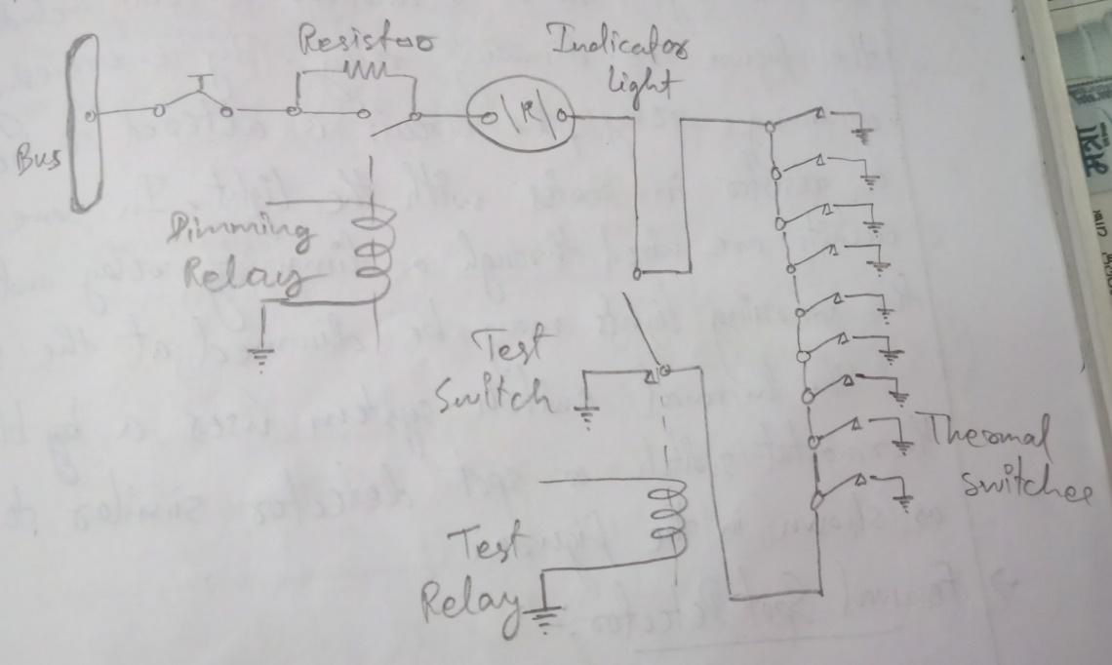
Fig: Thermal Switch with Fire Circuit
If the temperature rises above a set value in anyone section of the circuit, the thermal switch shows the light circuit to indicate the presence of a fire or overheat condition. No set number of thermal switches is required; the exact number is determined by the manufacturer. In some installation several thermal detectors are connected to one light, on others, there may be one light switch connected. Some warning lights are pushed to test. The burn is tested by pushing it to an auxiliary test circuit. The circuit in the figure includes a test relay. With the relay in contact, as shown in the figure, there are two possible path for the current flowing from switches to light. This is an additional safety features. Energising the test relay completes the circuit series and checks all the light. There is another circuit included in the figure i.e. dimming relay. By energising the dimming relay, the circuit is altered to include a resistor in series with the light. In some installation, circuits are wired through a dimming relay and all the warning lights may be dimming at the same time.
The thermal switch system uses a bi-metallic thermostat switch or spot detector similar to span as shown in the figure.
Fenwal Spot Detector
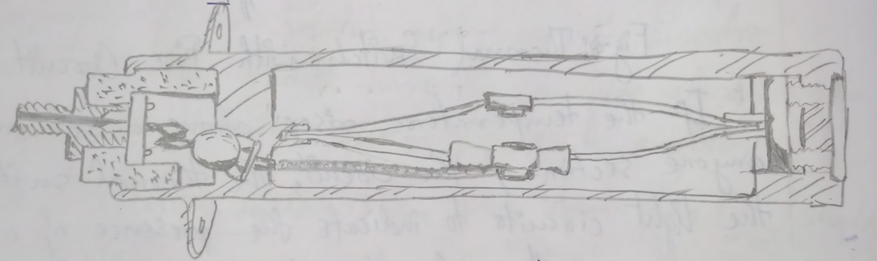
These are wires in parallel between two loops of wiring. Thus, the system can withstand one fault, either an electrical open circuit or a short to the ground without sounding a false warning. In case of five or overheat condition, the spot detector switch closes and complete to sound on another.
The fenwal spot detector system operates without a control unit. When an overheat condition or fire causes the switch in a detector to close, the alarm bell sounds and a warning light for the affected area is lighted.
Thermocouple System
The thermocouple fire warning system operates on an entirely different principle than the thermal switch system. The system consist a relay box, warning lights and thermocouple.
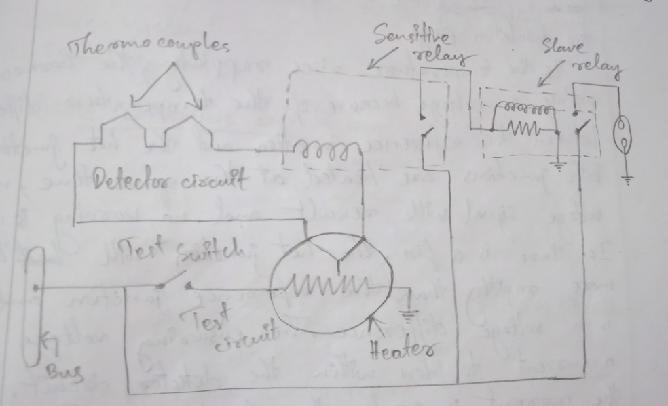
Fig: Thermocouple Fire Warning System
The wiring system of thermocouple may be divided into following circuit as shown in figure:-
- Detector circuit
- Alarm circuit
- Test circuit
The relay box contains two relays, the sensitive relay and the slave relay and the thermal test unit. The relay controls the warning lights and the thermocouples control the operation of the relay.
Working Principle
The thermocouple is constructed of two dissimilar matters such as chromel constantan. The point where the metals are joined and will be exposed to the heat of the fire is called hot junction. There is also a reference junction enclosed in a dead airspace between two insulation plugs.
If the temperature rises rapidly, the thermocouple produces a voltage because of the temperature difference between the reference junction and the hot junction. If both junctions are heated at the same time, no voltage signal will result and no warning is given. If there is a fire, the hot junction will heat more rapidly than the reference junction and there is a voltage difference. The ensuring voltage causes a current to flow within the detector circuit. Anytime the current is greater than 4miliampere (0.004A), the sensitive relay will flow. This will complete a circuit to the aircraft power system to the coil of slave relay which closes and completes the circuit to the fire warning light. When the sensitive relay opens, the circuit to the slave relay is interrupted and the magnetic field around its coil collapses, so there will be no alarm sign.
Continuous-Loop Detector System
A continuous loop detector or sensing system permits more complete coverage of a fire hazard area than any type of temperature detectors. These continuous loop systems are the several of thermal switch system. They are overheating system, heat sensitive unit that complete electrical at a certain temperature. There are two most common types continuous loop detector system:-
- Kidde system
- Fenwal system
Kidde Continous Loop System
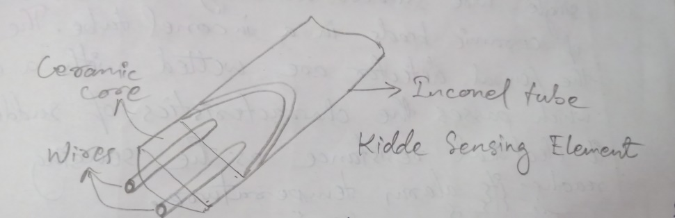
In the kidde continuous loop system, (as shown in figure) two wires are embedded in a special ceramic core. One of the two wires in the kidde sensing element is welded to the case at each end and acts as an internal ground. The second wire is a hot lead (above ground potential) that provides a current signal when the ceramic core material changes its resistance with a change in temperature. The kidde sensing elements are control unit. This unit constantly measures the total resistance of the fall sensing row. The system senses the average temperature as well as any single hotspot.
Fenwal Continous Loop System
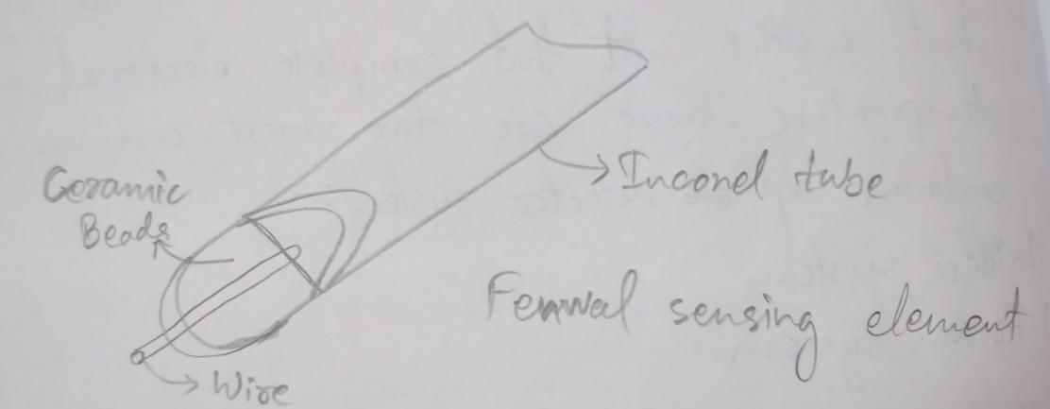
The fenwal system (as shown in figure) uses single wire surrounded by a continuous string of ceramic beads in an Inconel tube. The beads in the fenwal detector are wetted with a eutectic salt which passes the characteristics of suddenly lowering it electrical resistance as the sensing element reaches its alarm temperature.
The fenwal system uses a magnetic amplifier control unit. This system is non-averaging but when sound and alarm of its sensing element reaches its alarm temperature. In both the kidde and fenwal element, the resistance of the ceramic or eutectic salt core material prevents electric current from flowing at normal temperature. In case of fire or overheat condition, the core resistance drops and current slows between the signal wire and ground and flows between the signal wire and ground and energising the alarm system. Both systems continuously monitor temperature and both will automatically reset following a fire or overheat alarm after whole internal condition is removed or the fire is extinguished.
Overheat Warning System
It is used on some aircraft to indicate the high area temperature that may lead to a fire. The number of overheat warning system varies with the aircraft. On some aircraft, they are provided for each engine turbine and each nacelles and on others they are provided for wheel-well areas and for the pneumatic manifold. When an overheat condition occur in a detector area, the system causes a light on the fire control panel flash. In, most of the system, the detector is a type of thermal switch contacts are on spring struts which is closes whenever the meter case is expanded by the heat. One contact of each detector is grounded through the detector mounting bracket and the other contacts of all detectors connect in-parallel to the close loop of the warning light circuits.
When the detector contacts closed, a ground is provided for the warning light circuit and current then flows from an electrical bus through the warning lights and this is the reason to light flash on and off to indicate an overheat condition.
Lindbery Fire Detection System (Continous)
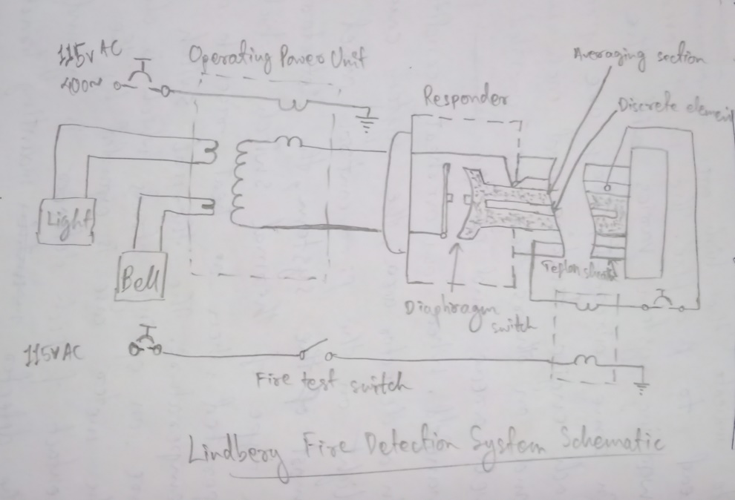
It is a continuous element type detector consisting of a stainless steel tube containing a discrete element. This discrete element has been processed to absorb gas in proportion to the operating temperature set point. When the temperature rises (due to fire or overheat condition) to the operating temperature set point, the heat generated causes the gas to be released from the element. These released gases causes the pressure in the stainless steel tube to increase.
This pressure rise mechanically actuates the diaphragm switch in the responder unit, activating the warning lights and the alarm bell. A fire test switch is used to test the sensor, expanding the trapped gas; the pressure generated closes the diaphragm switch activating the warning system.
Types of Fire
The national fire protection association has classified fire into 3 categories:-
- Class A-> It is defined as fires in ordinary combustion materials.
e.g. wood, cloth, paper, etc.
- Class B-> It is defined as fire in flammable products.
e.g. petroleum, or other flammable combustible liquids, grease, solvents, paints etc
- Class C-> It is defined as fire involving energized electrical equipment where the electrical non-conductive extinguishing media is important. In most case, where Class C fire is there, the most important task is to de-energise the electrical equipment first.
Firezone Classification
- Class A zone-> Zones having large quantities of air flowing past regular arrangement of similar shaped obstruction. The power section reciprocating engine is usually of this type.
- Class B zone-> Zones having large quantities of air flowing past aero-dynamically clean obstruction. Heat exchanger ducts and exhaust manifolds are usually of this type.
- Class C zone-> zones having relatively small airflow. An engine accessory compartment separated from power section is of this type.
- Class D zones-> Zones having very little or no airflow. These include wing compartment and wheel-wells where little ventilation is provided.
- Class X zones-> Zones having large quantities of air flowing through them and are of unusual construction making uniform distribution of the extinguishing agent very difficult.
Ice and Rain Protection
The rain, snow and ice are transportations and ancient enemies. Under certain atmospheric condition, there are 2 types of ice encounter during flight are rime and glaze. Rim ice forms a rough surface on the aircraft leading edge. It is rough because the temperature of the air is very low and it freezes the water before it has time to spread.
Glaze ice forms a smooth, thick coating over the leading edges of an aircraft. Ice may be expected to form whenever there is visible moisture in the air and the temperature is never below freezing.
Fig-> Stalling Speed Increases
Icing Effect
Ice on the aircraft affects its performance in many ways. Ice build-up increases drag and reduces lift. It causes destructive vibration and hampers true instrument readings. Control surfaces become unbalanced or frozen. Fixed slots are filled and movable slots jammed. Radio reception is hammered and engine performance is also affected.
Ice Prevention
Several means of methods are used to prevent and control ice formation are used in aircraft todays;
- Heating surfaces from hot air
- Heating by electrical element
- Breaking of ice formation usually by inflatable boots
- Alcohol spray
A surface may be anti-iced either by keeping it dry or by heating to a temperature that evaporates water upon needed or by heating the surface just enough to prevent freezing or the surface may be de-iced by allowing ice to form and then removing it.
Ice may be controlled on the aircraft structure by the following methods:-
Location of ice | Methods of control
- Leading edge of the wing | - Pneumatic and thermal
- Leading edges of vertical and horizontal stabilizer | - Pneumatic and thermal
- Windshields, windows and radomes | - Electrical or alcohol
- Heater or engine air inlet | - Electrical
- Pitot-tube | - Electrical
- Flight control | - Pneumatic and thermal
- Propeller blade leading edge | - Electrical or alcohol
- Carburettor | - Thermal or alcohol
Pneumatic De-Icing System
This system use rubber de-icer called boots or shoes attached to the leading edge of the wing and stabilizer. The de-icer is composed of a series of inflatable tubes. During operation, the tubes are inflated with pressurised air and deflated as shown in figure.
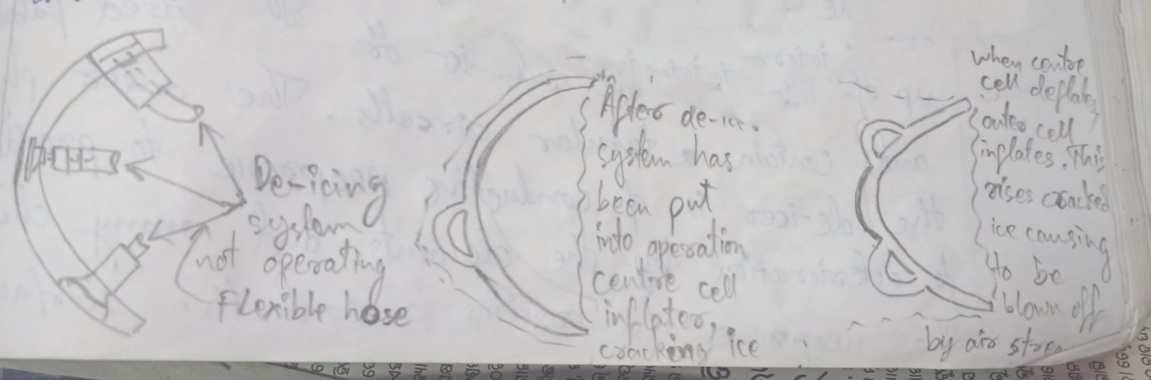
This inflation and deflation cause the ice to crack and break-off. The ice is then carried away by the airstream. De-icer tubes are inflated by engine driven air-pump (vacuum pump) or by the air-bleed from gas turbine engine compressor. The inflation sequence is controlled by either a centrally located distributer valve or by solenoid operated valves located adjacent to the de-icer air inlets. De-icer boots are installed along the wing with different sections operating alternatively and symmetrically about the fuselage. This is done so that any disturbances caused by inflated tube will be kept minimum by inflating only short sections at each wing at a time.
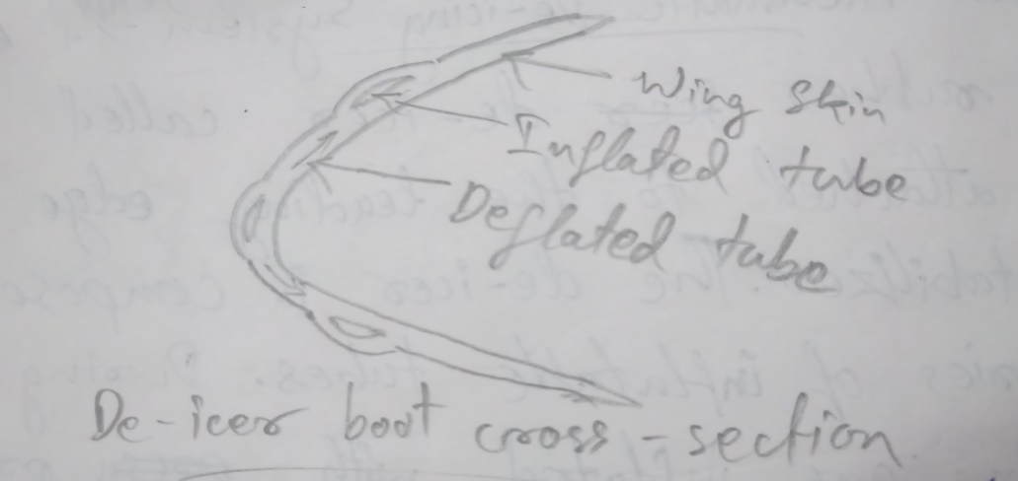
De-Icer Boot Construction
De-icer boots are made up of soft pliable rubber or rubberised fabric and contain tubular air cells. The outer ply of the de-icer is of conductive neoprene to provide resistance to deterioration by the elements and many chemicals. The neoprene also provides a conductive surface to dissipate static electricity charges. This charges if allow to accommodate would eventually discharge through the boot to the metal skill banner. De-icer boots are attached to the leading edge of the wing and tail surfaces with cement or hiring strips and screws or a combination of both. The new type de-icer boots (as shown in figure) are completely bonded to the surface with cement. The trial edges of this type of boots are tapered to provide a smooth airflow. By eliminating the fairing strips and screws, this type of installation cuts down the weight of the de-icer system.
In addition to de-icer boot, the major component of the pneumatic de-icing system and a source of pressurised air, oil separator, air pressure and suction relief valves and a suction regulator and pressure regulator and a shut of valves, an inflation timer and a control valve. A schematic typical de-icer system is shown in the figure.
In this system, air pressure for system operation is supplied by air bleed from the engine compressor. The bleed air from the compressor is ducted to a pressure of the turbine bleed air to the de-icer system pressure. An ejector located downstream of the regulator provides the vacuum necessary to keep the boots deflated.
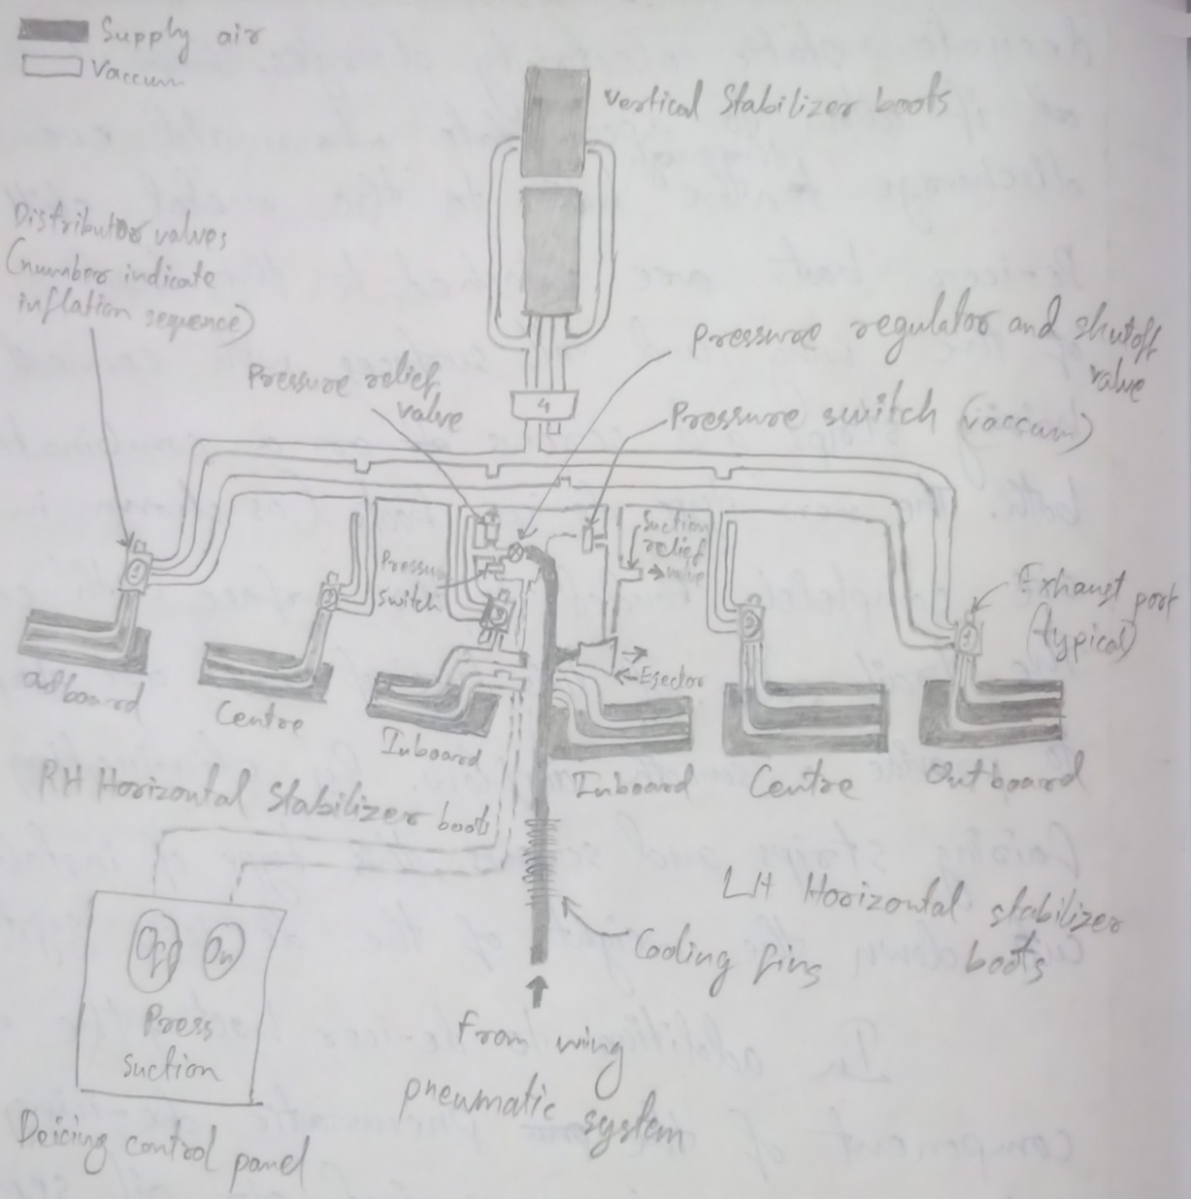
The air pressure and suction relief valves and regulators maintain the pneumatic system pressure and suction at the desired value. The timer is essentially a series of switch circuit actuated successively by a solenoid rotating step-switch. The timer is energized when the switch is placed on ‘ON’ position.
Operation
When the system is in ‘ON’ position, the de-icer port in the distributor valve is closed to vacuum and system operating pressure is applied to the de-icer connected to the port. At the end of the inflation period the de-icer pressure port is shut-off and the air in the de-icer flows overboard through the exhaust port. When the air flowing from the de-icer reaches a low pressure (approximately 1PSI) the exhaust port is closed. The vacuum is reapplied to the de-icer port to exhaust the remaining air from the de-icer. This cycle is repeated as long as the system is operated. If the system is turned off, the system time automatically returns to its starting position.
De-Icer System Components
Engine Driven Airpump
It is of the rotary, 4 vanes; positive displacement typed and is mounted on the accessory drive gear box of the engine. The compression side of each pump supplies air pressure to inflate the inlet side to hold down.
Safety Valves
An air pressure safety valve is installed on the pressure side of some types of engine driven pump. The safety valve exhaust excessive air at high pump RPM when a predetermined pressure is reached, the valve is reset and not be adjustable.
Oil Separator
An oil separator is provided for each wet-type air pump. Each separator has an air inlet port, outlet port and an oil drain line which is back to the engine oil sump. The oil separator removes approximately 75% of air pump.
Suction Regulation Valve
An adjustable suction regulating valve is installed in each engine ‘nacelle’. One side of the each valve is piped to the inlet (suction) side of the engine driven air pump and the other side to the main suction manifold line. The purpose of the suction valve is to maintain the de-icer system suction automatically. This valve may be adjusted to obtain the desire de-icing value. The value is increased by turning the adjusting screw anti-clockwise and decrease by turning it clockwise.
Thermal Anti-Icing System
Thermal system used for the purpose of preventing the formation of ice or for the de-icing aerofoil leading edges, usually use heated air ducted span wise along the inside of leading edge of the aerofoil and distributed around its inner surface.
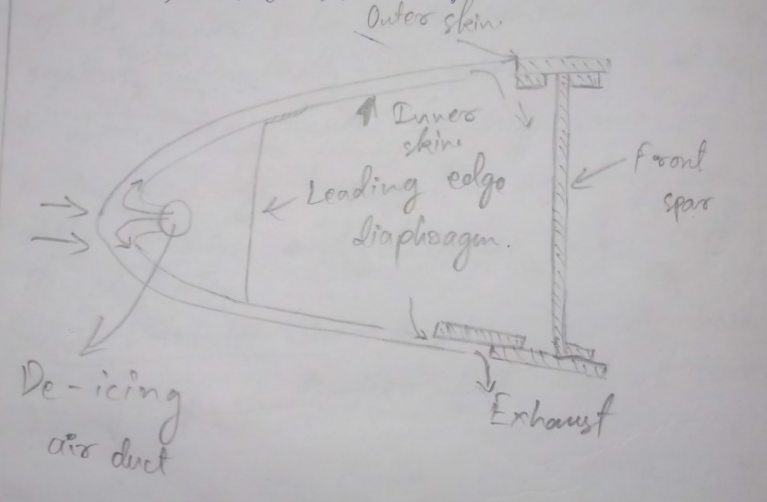
Fig: - A Typical Heated Leading Edge
There are several methods used to provide heated air to the system. These include bleeding hot air from the turbine compressor, engine exhaust heat exchanger and ram air heated by a combustion heater. In installation where protection is provided preventing the formation of ice, heated air is supplied continuously to the leading edges as long as the anti-icing system is on. The portions of the aerofoil which must be protected from ice formation are usually provided with a closely spaced double skin, the heated air carried through the ducting is passed into the gap. This provides sufficient heat to the outer skin to melt the layer of ice next to the skin or to prevent its formation. The air is then exhausted to the atmosphere at the wing tip or at points where ice formation would be critical.
Ground De-Icing of Aircraft
The presence of ice on an aircraft may be the result of direct precipitation. Formation of frost on integral of fuel tank after prolongs flight at high altitude or accumulation on the landing gear following taxing through snow or slush. Any deposits or snow, ice or frost under external surface of the aircraft make drastically effect its performance. This may be due to reduce in aerodynamic lift and increased aerodynamic drag resulting from the disturbed airflow of over the aerofoil surfaces.
The operation of the aircraft may also be seriously affected by the freezing or moisture in control hinges valves, micro switches or by injection of ice into the engine. When the aircrafts are hinged to melt snow or frost, any melted ice or frost may freeze again if the aircraft is subsequently moved into sub-zero temperature. So, major should be taken while the aircraft is in ground must also prevent re-freezing of the liquid.
Frost Removal
Frost deposits can be removed by placing the aircraft in a warm hang or by using a frost removal. These fluids normally contain ethylene glycol or isopropyl alcohol and can be applied either by spray or hand. It should be applied within two hours of flight. De-icing fluid may adversely affect windows or the exterior finish of the aircraft, so, this type of fluid used only by the recommendation of aircraft manufacture.
Removing Ice or Snow Deposit
Probably the most difficult deposit to deal with is deep wet snow when ambient temperature is slightly about the freezing point. This type of deposit should be removed with a brush or squeegee. Use care to avoid damage to antennas vents stall warning devices, vortex generator etc. moderate or heavy ice and residual snow should be removed with ice deposits by force. After completion of the de-icing operation inspect the aircraft to ensure that its condition is satisfactory for flight. Check the drain and pressure sensing ports for observations. Control surfaces should be removed to ascertain that they have full or free element and the operation of up-locks and micro-switches should be check. If the snow is in the turbine section and the compressor is not run for this region, hot air should be blown through the engine until the rotating parts are free.

Windshield Icing Control System
In order to keep the windshield areas, free of ice, frost and fog, window anti-icing, de-icing, de-fogging and de-misting systems are used. The systems are very accordance to the type of aircraft and its manufacturer. These systems can be electric, pneumatic or chemical depending upon the type and the complexity of the aircraft.
One of the most common method for controlling ice formation and fog on modern aircraft windows is the use of an electrical heating element built into the windows.
Electrical Icing Control System
High performance transport category of windshields is typically made up of laminated glass, polycarbonate, or similar ply materials. Typically, clear vinyl ply 2 is also included to improve performance characteristics. These laminates create the strength and impact resistance of the windshields as a subject to a wide range of temperature and pressure. The laminate construction facilitates the inclusion of electric heating element in the glass layer, which is used to keep the windshield clear of ice, frost and fog. The elements can be in the form of resistance wires or a transparent conductive material may be used as one of the wind of plies. The below figure shows section of a laminated windshield:-
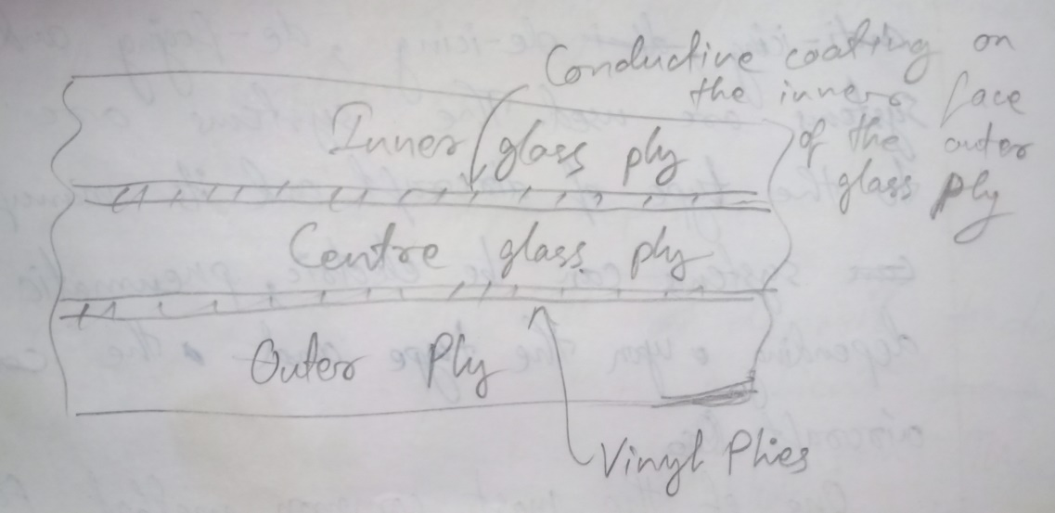
To ensure enough heating is applied on the outside of the windshield, heating elements are placed on the inside of the outer glass ply. An electrical heated windshield system includes windshield auto-transformer and heat control relay, heat control toggle switches, indicating lights, windshield control unit, temperature sensing element laminated in the panel.
On some aircraft, thermal electrical switches automatically turn the system on, when the air temperature is low enough for the icing or frosting to occur. The system may stay on all the time during such operation or on some of the aircraft; it may operate with a pulsating on and off pattern. Thermal overheat switches automatically turn the system off in case of an overheating condition which could damage the transparent area.
Drwbacks of Electrical Heated Windshield System
There are several problem associated with electrical heated windshields. These include delamination, scratches, arcing and discolouration.
Delamination (separation of the plies) although undesirable and is not harmful if it is within the limit structurally. Delamination affects the optical qualities of the panel.
Arcing is a windshield panel usually indicates that there is a breakdown in the conductive coating. When surface cracks are formed in the glass ply, simultaneously release of surface compression and internal tension stress in the highly tempered glass can result in the edges of the crack and the conductive coating is parting slightly. Arcing is produced where the current jumps this gap particularly where these cracks are parallel through the window busbars. When arcing exists, there is chance of overheat condition and can cause further damage to the panel.
Electrically heated windshields are transparent to directly transmitted lights but they have a distinctive colour when viewed by reflected light. Normally, discolouration is not a problem but it affects the optical qualities.
Windshield scratches are more prevalent on the outer glass ply. The best solutions of scratches that clean the windshield wiper blades as frequently as possible and should be never operated on a dry panel since it increase the chances of damage the surface.
Rain Eliminating System
When rain falls on a windshield during flight, it becomes a hazard and must be eliminated. To provide a clear windshield, rain is eliminated by wiping it off or blowing it off. A third method of rain removal involves chemical rain repellents. Rain is blown from the windshield of some aircraft by air from jet nozzles located beneath the windshield. On other aircraft windshield wipers are used to eliminate the rain. The windshield wiper of the aircraft works on the same principle as in the automobile.
Electrical Windshield Wiper System
In an electrical windshield wiper system, the wiper blades are driven by electric motor which receives the power from aircraft electrical system. The below figure shows a typically electrical windshield wiper installation;
An electrically operated wiper is installed on each windshield panel. Each wiper is driven by a motor converter assembly. The motor converts the rotary motion of the motor reciprocating motion to operate wiper arms.
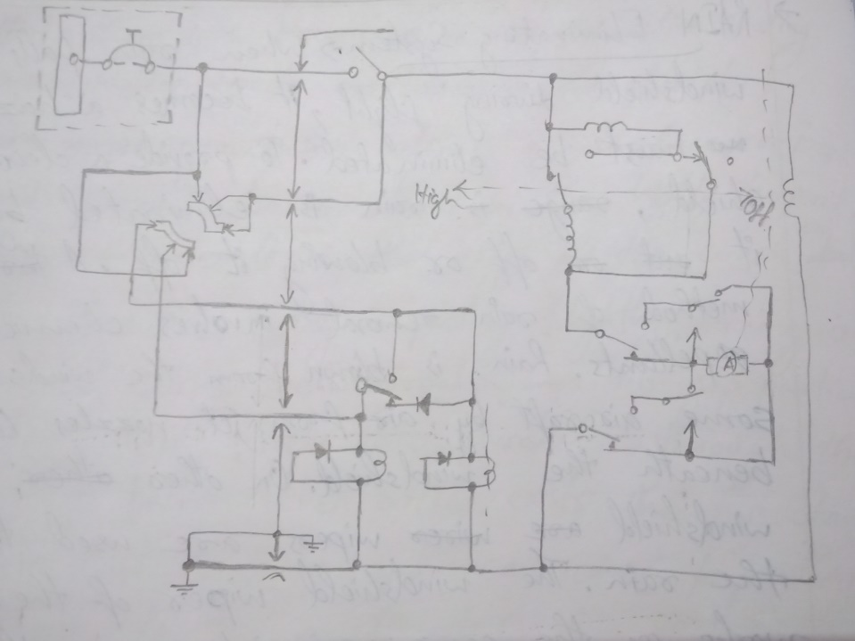
The windshield wiper is controlled by setting the wiper control switch to the desired wiper speed as shown in above figure. When the high position is selected, relay 1 and 2 are energised. With both relays energies field 1 and 2 are energized in parallel. The circuit is then completed and the motors operate at an approximately speed of 250 stroke per min. When the low position is selected, relay 1 is energised. This causes field 1 and 2 to be energized in series. Then the motor operates at approximately 160strokes per minute. Setting the switch to the up position allow the relay contacts to return to their normal position. However, the wiper motor will continue to run until the wiper arm reaches the “park position”.
Hydraulic Windshield Wiper System
Hydraulic windshield wipers are driven by pressure from aircrafts main hydraulic system. The below figure shows the components of a hydraulic windshield wiper system:-
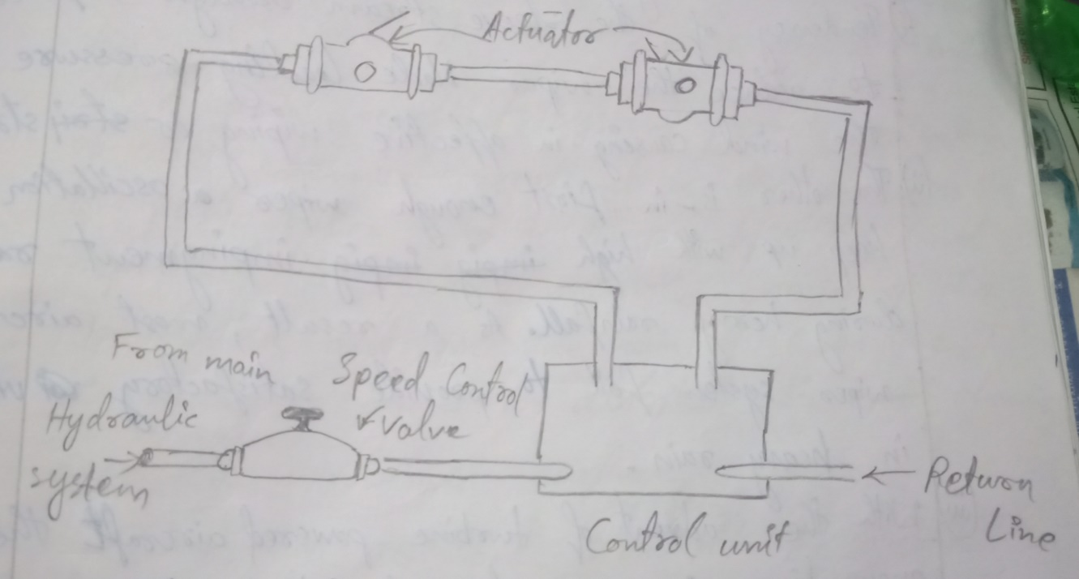
The speed control valve is used to start, stop and control the operating speed of the windshield wiper. The speed control valve is a type of variable restrictor. Turning the handle of these valves counter-clockwise increases the size of the fluid opening, the flow of fluid to the control unit and therefore, the windshield wiper. The control unit directs the flow of fluid to the wiper actuator and return fluid discharge from the actuator to main hydraulic system. The control unit also alternates the direction of hydraulic flow to each of the two wiper actuator. The wiper actuator converts the hydraulic energy into reciprocating motion to drive the wiper arm back and forth.
Pneumatic Rain Removal System
Windshield wipers characteristically have 2 basic problem areas:-
- Tendency of the sleeve stream aerodynamic forces to reduce the wiper blade leading pressure on the wind causing in affective wiping or streaking.
- The other is in first enough wiper oscillation to keep up with high impingement rates during heavy rainfall. As a result, most aircraft wiper system fails to provide satisfactory vision in heavy rain.
- With the advent of turbine powered aircraft the pneumatic rain removal system becomes feasible. This method uses high pressure, high temperature, engine compressor bleed air which is blown across the shield. The air-blast forms a barrier that prevents the rain drop striking the windshield surface.
Windshield Rain Repellant
When water is poured onto clean glass, it spreads out evenly. Even if the glass is held at sleep angle or subjected to air velocity, the glasses remain wetted by thin film of water. However, when the glass is treated with certain chemicals, a transparent film is formed which causes the water to behave like mercury on glass. This principle lends itself quite naturally to removing rain from the aircraft windshield. The high velocity sleep stream continuously removes the water, leading large part of window dry.
A rain repellent system permits application of the chemical repellent by a switch of push button in the cockpit. The liquid repellent is squirted onto the exterior of the windshield and uses the rain itself as the caring agent to distribute the chemicals over the windshield surface.
The rain repellent system shouldn’t be operated on dry windows because heavy undiluted repellent will restrict windows visibility.
Maintenance of Rain Eliminating System
Maintenance performed on windshield wiper system consists of operational checks, adjustment and troubleshooting. An operational check should be performed whenever a system component is replaced or whenever the system is suspected of not working property. During the check make sure that the windshield area covered by the wiper is free of foreign matter and is kept wet with the water.
Adjustment of the windshield wiper system consist of adjusting the wiper, blade tension, the angle at which the blade sweeps across the windshield and proper parking of the wiper blade.
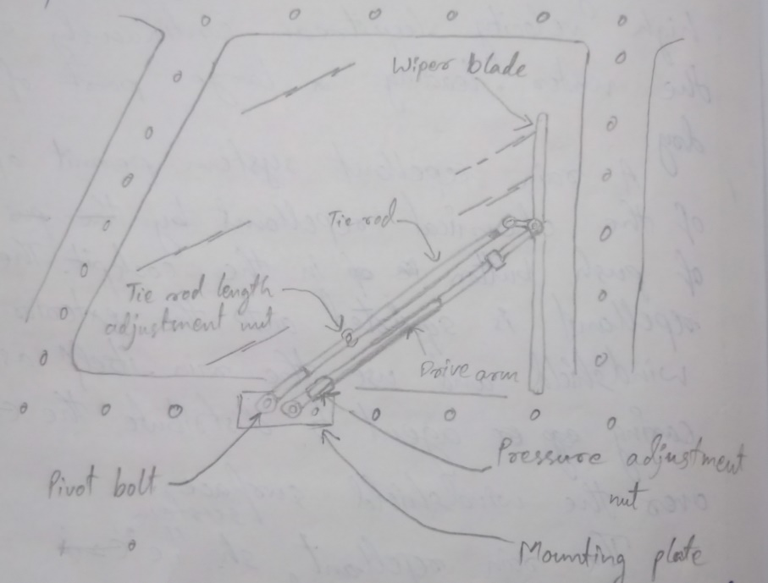
The above figure shows the adjustment points on a typical wiper blade installation. One adjustment is that the tie rod length. The tie rod connects the wiper blade holder to a pivot bolt next to the drive shaft. With the drive arm and tie nut connected to the wiper blade holder and the wiper converter. This linkage permits the wiper blade to remain parallel to the windshield post during its travel from one side of the windshield to other. Another adjustment is that which is required for proper parking of the windshield wiper blades. When they are not operating, the wiper blade should move to a position where they will not interfere with the vision.
Cabin Atmosphere
Control System
Need for Oxygen
Oxygen is essential for most leaving processes. Without oxygen man and other animals die very rapidly. But before this extreme stage is reached, a reduction in normal oxygen supply to the tissues of the body can produce important change in body functions, thought processes and degree of consciousness. The sluggish condition of mind and bogy caused by deficiency or lack of oxygen is called hypoxia. There are several causes to hypoxia but the one concern in aircraft operation is the decrease in partial pressure of the oxygen in the lungs.
From sea level to 7000feet, above sea level the oxygen contains pressure in the atmosphere remains sufficiently high to maintain almost full saturation of the blood, thus, ensure normal body and mental function. At high altitude there is decrease in barometric pressure which resulting in oxygen contained of inhaled air. The oxygen saturation of the blood is about 90%. Long exposure to this altitude results in headache and fatigue. At 15000feet the saturation drops to 91%. At 22000feet above sea level the blood saturation is 68% and above 22000feet the oxygen contained in the blood decrease to 50-55% and will cause unconsciousness.
Pressurisation System
When an aircraft is flown at high altitude, it burns less fuel for a given air speed than it does for the same speed at a lower altitude. In other words, the airplane is more efficient at high altitude. In addition, bad weather and turbulence can be avoided by flying in the relatively smooth air above the storms. Aircraft, which do not have pressurisation and air conditioning system, are usually limited to lower altitude.
A cabin pressurisation system must accompany several functions if it is to assume adequate passenger comfort and safety. It must be capable of maintaining cabin pressure altitude of approximately 8000feet at any design crushing altitude of aircraft. The system must also be designed to prevent rapid changes of cabin altitude which may be uncomfortable or injuries to passenger and crew. In addition, the pressurisation system should permit a reasonably fast exchange of air from inside to out of the cabin. This is necessary to eliminate odours and to remove state air.
Basic Pressurisation System
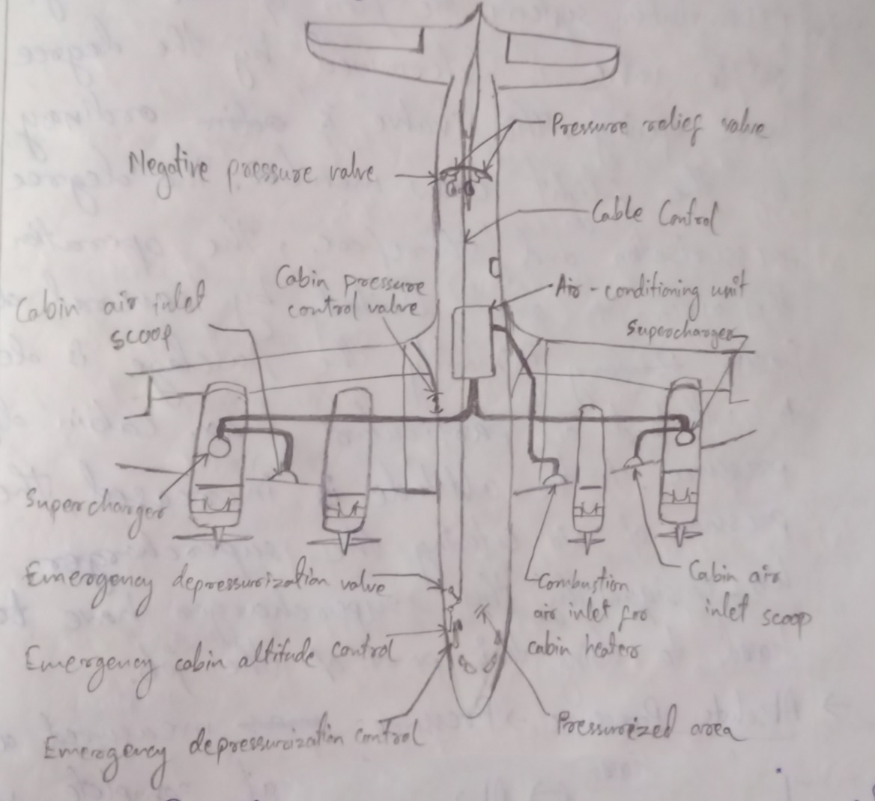
In the typical pressurisation system, the cabin, the flight compartment and baggage compartment are incorporated into a sealed unit which is capable of containing air under a pressure higher than outside atmospheric pressure. Pressurised air is pumped into the shield fuselage by cabin supercharger which delivers a constant volume of air at all altitudes. Air is released from the fuselage by a device called an outflow valve. Since the super charger provides a constant inflow of air to the pressurised area, the outflow valve by regulating the air exit is the major controlling element in the pressurisation system. The flow of air through an outflow valve is determined by the degree of valve opening. This valve is ordinary controlled by the flight crew member. The degree of pressurisation and therefore, the operation of the aircraft are limited by several design factors. Primarily the fuselage is designed to withstand a particular maximum cabin differential pressure. As the altitude is increased, the pressure of air entering the supercharger becomes less, consequently the supercharger have to work hard to doing their part of the job.
- Absolute Pressure-> Pressure measured along scale which has a value at complete vacuum.
- Absolute Temperature-> Temperature measured along a scale which has zero value at that point where there is no molecular motion. (-273.1˚C).
- Adiabatic-> The adiabatic process is one in which no heat is transferred between the working substance and the outside source.
- Aircraft Altitude-> The actual height above the sea level at which the aircraft is flying.
- Ambient Temperature-> The temperature in the area immediately surrounding the object under discussion.
Air Consitioning and Pressurisation System
The cabin air conditioning and pressurisation system supply conditioned air for heating and cooling the cockpit and cabin spaces. This air also provides pressurization to maintain a safe, comfortable cabin environment. In addition to cabin air conditioning, it is also been used to prevent build-up and consequent damage to the equipment.
Some of the air conditioning system installed in modern aircraft utilizing air turbine refrigerating unit to supply cold air. These are called “air cycle system”. Other modern aircraft utilize a compressed gas cooling system. This refrigeration unit is quite similar in operation to a common household refrigerator. System utilising this refrigeration principle are called “vapour cycle system”.
Basic Requirements
The basic requirements for successful functioning of cabin pressurisation and air conditioning system are:-
- A source of compressed air for pressurisation and ventilation. Cabin pressurisation sources can be either engine driven compressor, independent cabin super-chargers or air bleed directly from engine.
- A means of controlling cabin pressure by regulating the outflow of air from the cabin. This is accompanied by cabin pressure regulator and an outflow valve.
- A method of limiting the maximum pressure differential to which the cabin pressurised area to be subjected. Pressure relief valves, relief valves and dump valves are used to accomplish this.
- A means of regulating the temperature of the air being distributed to the pressurised section of the airframe. This is accomplished by refrigeration system, heat exchanger, and control valve and cabin temperature control system.
- The section of the aircraft which are to be pressurised must be sealed to reduce inadvertent leakage of air to a minimum. This area must also capable of safety withstanding the maximum differential pressure between the cabin atmospheres to which to will be subjected.
Direction Indicating Instrument
Magnet and its properties
First of all, let us consider, first 3 principle properties of a permanent magnet:-
- It will attract other cases of iron and steel.
- It’s power of attraction is concentrated at each end.
- When suspended so as to move horizontally, it always comes to rest in an approximately north and south direction.
The end of the magnet which seeks north being called the North Pole and the end which seeks the south called South Pole. When 2 such magnets are brought together so that both North Pole and South Pole face each other, a force is created which will keep the magnets apart.
The region in which the force exerted by a magnet can be detected is known as magnetic field. Such a field contains magnetic flux which can be represented in direction and density by lines of clocks.
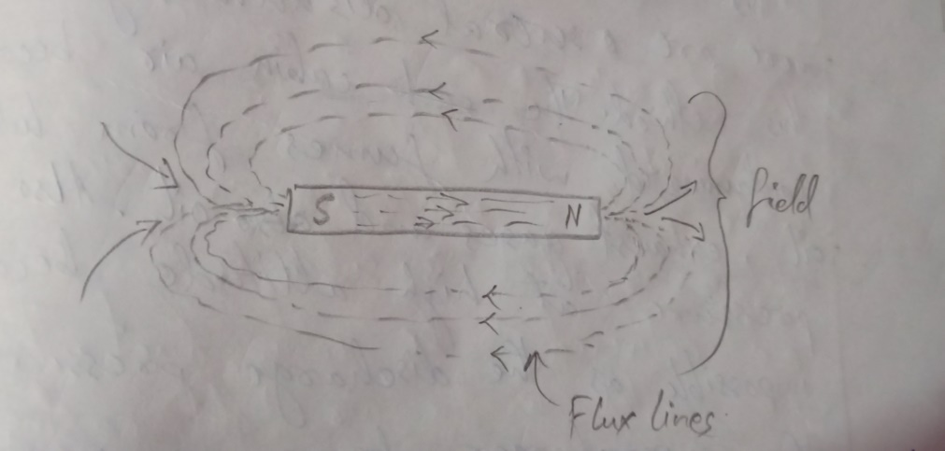
The conventional direction of the lines of clocks outside a magnet is from the North Pole to South Pole. The lines are continuous and unbroken, so that inside the magnet there direction is from South Pole to North Pole. The symbol for magnetic flux is “Ø” and the unit is weber ‘wb’.
Sources of Cabin Pressure
Reciprocating engine internal super charger provides a simplest means of certain pressurisation. This is accompanied by ducting air from a manifold which supplies compressed air from the super charger to the piston. This arrangement can be used to only when the engine carburettor is downstream of the super charger. When the carburettor is upstream of the super charger, this method can be used since, the compressed air contains fuel. There are several disadvantages in using this method. The cabin air becomes contaminated with fumes from lubricating oil, exhaust gases and oil. Also cabin pressure at high altitude become impossible as the discharge pressure of the supercharger decreases nearly the ambient pressure.
With the gas turbine engines, the cabin can be pressurised by bleed air from the engine compressor. Usually the air bleed from the engine compressor is sufficiently free from contamination and can be used safely from cabin pressurisation. Even though there is no contamination, there are several disadvantages using bleed air from the turbine engine compressor. These are:-
- The possibility of the contamination of air from lubricant or fuel in the event of leakage.
- Dependence of the air supply on the engine performance.
- Because of the many disadvantages associated with the pressuring dources, independent cabin pressure has been designed. These compressor can be engine driven through accessory drive gearing or can be powered by bleed air from the turbine engine compressor.
- Generally, the compressor can be separated into two groups;
- Positive displacement compressor
- Centrifugal compressor
Positive Displacement Compressor
In this group, reciprocating compressor, vane type compressor and roots blower exist. The first 2 are not suitable for aircraft cabin pressurisation because of the large quantity oil present in the air delivered to the cabin.
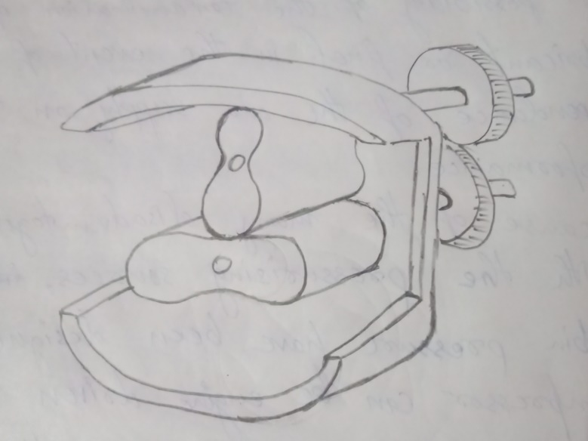
The action of a route type blower as shown in the figure is based on the intake of a predetermined volume of air which is subsequently compressed and delivered to the cabin duct. The rotors are mounted in the air tight casing on 2 parallel shafts. The lobes do not touch each other or casing or both the rotor turns at same speed. Air enters the spaces between the lobes, is compressed and delivered to the cabin air duct.
The supercharger housing is usually thinned on the external surface to increase the cooling air. The cooling effect is sometimes increased by shrouding the supercharger housing and passing a stream of air through it. Air cooling is also used to reduce the temperature of the internal parts the cooling air is ducted through drilled passage ways into the rotor cavities and is exploited at the inlet side of the supercharger cover.
To achieve an oil free delivery of air, the supercharger’s bearings are contained in separate charger. The rotor shaft can fitted in seals made of oil resistance rubber which prevents any lubricant from entering the casing.
Centrifugal Cabin Compressor
The operating principle of a centrifugal compressor is based on increasing the kinetic energy of the air passing through the impeller. With the compressor impeller rotation the induced air is not only accelerated but also compressed due to the action of centrifugal force. The kinetic energy of the air is then converted into pressure in the diffuser. There are two basic type of diffuser; vane less where the air enters the diffuser directly where or living the impeller and those have guide vanes. A schematic diagram of centrifugal compressor given in figure below:-
Supercharge Control
The function of the supercharger control system is to maintain a fairly constant volume of air output from the supercharger. This is accomplished in the system used in reciprocating engine aircraft by varying the drive ration of the supercharger. This is achieved by an automatic mechanism which samples the airflow output of the supercharger and through a variable speed drive gearbox, adjust the impeller speed whenever the airflow output varies from pre-set vary.
The Cabin Pressure Control System
It is designed to provide cabin pressure regulation, pressure relief and the means for selecting the desired cabin altitude in the isobaric and differential range.
A cabin pressure regulator, an outflow valve and a safety valve are used to accomplices this function.
Cabin Pressure Regulation
The cabin pressure regulator controls the cabin pressure to a selected value in the isobaric range and limits cabin pressure to a pre-set differential value in the different ways. The isobaric range maintains the cabin at constant pressure altitude during flight at various levels. It is used until the aircraft reaches the altitude at which the difference between the pressure inside and outside the cabin is equal to the highest differential pressure for which the fuselage structure is designed. Differential control is used to prevent the maximum differential pressure for which the fuselage is designed. The cabin pressure regulator is designed to control cabin pressure by regulator is designed to control cabin pressure by regulating the position of outflow valve. The regulator usually provides either automatic or manual control of pressure within the aircraft. A cabin pressure regulator is integral with outflow valve is illustrated in the below figure.
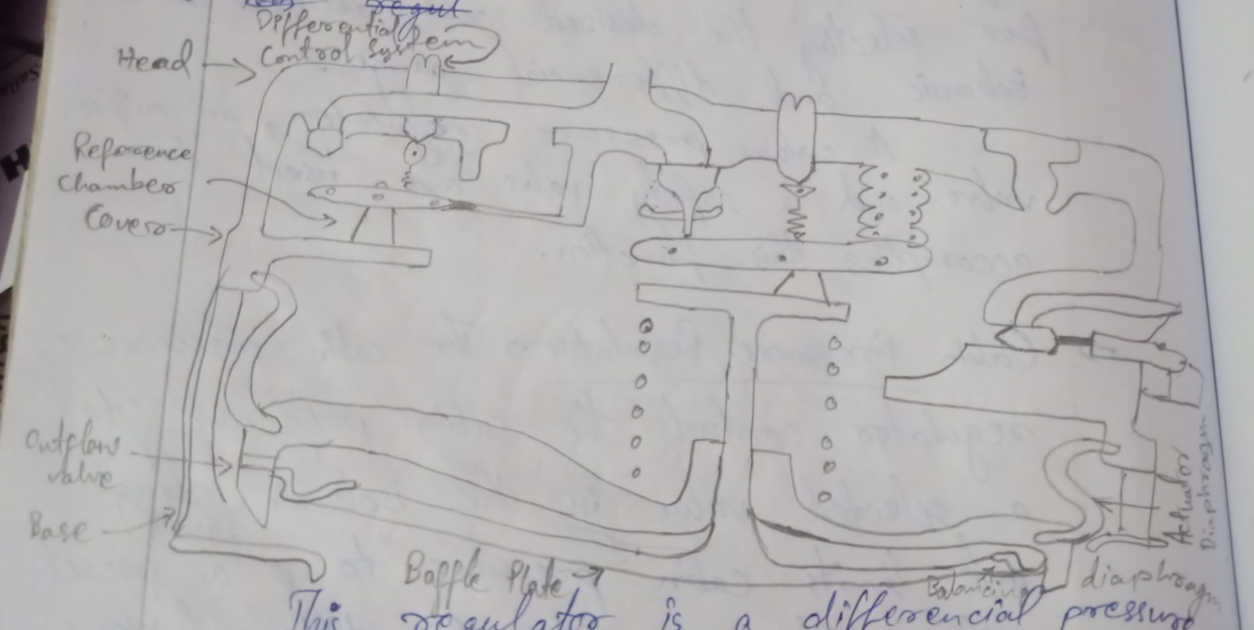
This regulator is a differential pressure type, normally closed, pneumatically controlled and operated. This type of regulator consists of two principle section; the head and reference chamber, the outflow valve and diaphragm section. The head and reference chamber section includes an isobaric control system, differential control system, a filter, a ground state valve, an atmospheric connection and a solenoid air valve. The outflow and diaphragm section contains a base, spring loaded outflow valve, an actuator diaphragm, a balance diaphragm and a baffle plate. The baffle plate is attached to the end of a pilot which extends from the centre of the corner assembly.
Working Principle
During on pressurisation condition, reference chamber pressure is sufficient to compress the isobaric bellow and opening the metering valves. Cabin air entering the reference chamber through the cabin air orifice flows to the atmosphere through the isobaric metering valve. As pressure increases in the cabin, the differential pressure in the outflow valve increases as well as the inner and outer phase also increases. This unseals the outflow valve and allows cabin air to flow through the atmospheric.
As the isobaric range is approached, the reference chamber pressure which has been decreasing at the same rate as the atmospheric pressure will expand the bellows and move the metering valve towards its seat. As a result, the isobaric control system modulates to maintain a substantially constant reference pressure throughout the isobaric range of operation.
Cabin Air Pressure Safety Valve
It is a combination of pressure relief, vacuum relief and duct valve. The pressure relief valve present cabin pressure for exceeding a predetermined difference (pressure above ambient pressure. The vacuum relief prevents ambient pressure from exceeding cabin pressure by allowing external air to enter the cabin when the ambient pressure exceeds the cabin pressure. The dump valve is actuated by the cockpit control switch when this switch positioned to ‘RAM’ cabin air to atmosphere.
Air Distribution
The cabin sir distribution system includes;
- Air ducts
- Filter
- Heat exchanger
- Silencers
- Non-return or check valves
- Humidifier
- Mass flow control sensor
- Mass flow meter
Air enters the cabin supercharger through a certain covered opening in the left engine oil cooler air-scoop. If the air inlet screens ices over, spring loaded through besides the spring opens allowing air by passing the screen. From the cabin supercharger the air passes through a firewall and shut up valve, a pressure relief valve and a silencer which damp-tents the supercharger noise and pollution. The air they pass through a flow central valve which governs the airflow rate to maintain the maximum gram per minute air flow.
Air Ducts
Ducts having circular or rectangular cross-section in used air distribution system.
Cabin air supply ducts are usually made from aluminium alloys stainless steel and plastic. Main ducts for air temperature, over 200˚C are made from stainless steel. Those parts of the ducting where the air temperature doesn’t 100˚C are usually constructed from soft aluminium. Plastic ducts, both rigid and flexible are used as outlet ducts to distribute the conditioned air.
Filter
The air delivered to a prescribed cabin from a supercharger or engine compressor may content dust particles, oil mist or other impurities.
Filters are generally incorporated into the ducting to clean the air.
Air Conditioning System
There are two types of air conditioning systems commonly used on aircraft.
- Air cycle air conditioning system
- Vapour cycle air conditioning system
Air cycle air conditioning is used on most turbine-powered aircraft. It makes use of engine bleed air or APU pneumatic air during the conditioning process. Vapour cycle air conditioning systems are often used on reciprocating aircraft. This type system is similar to that found in homes and automobiles. Note that some turbine-powered aircraft also use vapour cycle air conditioning.

